

BYTEZOOM HARVEST APPLICATION

TIME REPORT

Version 0.1  
January 07, 2024

|  |  |  |  |
| --- | --- | --- | --- |
| Date | Version | Changed By | Changes |
| January 7, 2024 | Version 0.1 | Maryna Nikolaienko | Original Version. |

Table of Contents

Bytezoom Harvest Application 4

Menu "Log Time" 4

Menu " Dashboard " 6

Menu " Time Report Project " 8

Menu " Time Report User " 10

Menu " Time Report Inconsistencies " 11

# Bytezoom Harvest Application

**Time Report**

Users can navigate to the Harvest Application using this link: <https://k2dev3.smartk2.bytezoom.com/Runtime/Runtime/Form/BZWD.Main.Form/>

Please use your SmartK2\UserName for logging in to the application. This will ensure that time entries you create will be correctly associated with you as system using AD authorization related to companies profile

**Time Report**

On the Left-pane menu of the HARVEST APPLICATION there’s a functional block named TIME REPORT. This purpose of this section is to allow recording the time spent on tasks that are related to a specified Project. Task information so entered is used for creating reports for Bytezoom and for customer invoicing. It’s designed to assist in monitoring hours used for each project to prevent overruns. Users can log hours, track project progress, generate reports, and analyze efficiency.

The Time Report section is divided into five blocks:

**- Log Time**

**-Dashboard**

**-Time Report Project**

**-Time Report User**

**-Time Report Inconsistencies**

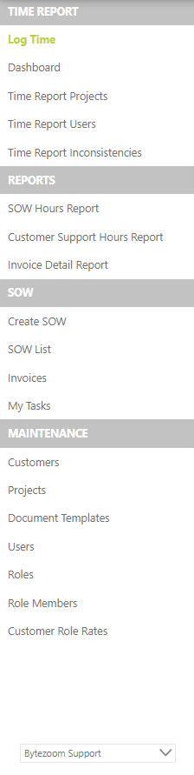

# Menu "Log Time"

First, let’s examine the "Log Time" menu, accessible to all user roles. The main window is divided into two parts. In the upper section, users can enter the time spent by selecting a date, with three buttons for the current and two previous dates and a calendar for earlier dates. Then, fill in the details by selecting a project, entering the time spent, specifying the ticket number, and describing the completed work.

When selecting a project, start typing its name, and the system will automatically suggest possible options from the projects available to you as a user. The date format can be entered using either a colon or a period, and the system will automatically convert the data into the required format.

For each project, an individual rounding is set when entering the time spent, the rounding can range from 5 to 30 minutes. The ticket number should be entered in the same way as it is listed in systems like Jira, or Asana. For tasks assigned by email, put the word “Email” in # Ticket field and put the details into the Task description. In the task description, it’s essential to detail all the actions that were taken during the completion of the task. When preparing the description, it’s essential to specify the system from which the task was sourced. Use a formulation like "Working on Jira ticket #CPP-743", then describe the nature of the task and how it was addressed. Conclude the description by indicating the tasks completion status. For example: Complete 100%. **Make sure that the wording is the description is well formed, because the customer will see this description on billing documents.** Once all the necessary information is filled in, press the "Log It" button.



*Below is a sample of how to fill it out:* 

Subsequently, the current entry will be added to the lower part of the screen, where users can modify or delete it if necessary, using the toolbar.



In the second part of the screen, beneath the toolbar, there’s a filter.

*Below is a sample of how to use it:*



Users also have access to the "Further Back In Time" button, which displays entries from an earlier period upon clicking.

***Note:*** If a maximum time usage is set for any project, adding an entry might trigger a warning message about exceeding the hour limit, and the entry won’t be saved.

***Note:*** If a user hasn’t been assigned to a specific project, they won’t be able to log time for that project.

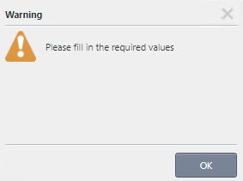If one of the mandatory fields is left unfilled and you press the “Log It” button, a message will appear indicating the need to fill in all required fields, with the relevant fields highlighted in red.

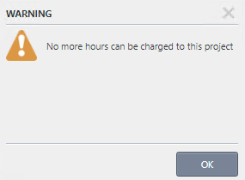If the logging of time used for a particular project is exceeded, a similar message will be displayed, and the entry will not be saved.

# Изображение выглядит как текст, снимок экрана, Шрифт Автоматически созданное описаниеMenu " Dashboard "

The next menu we will consider is "DASHBOARD". allows you to generate data for any time period, for a group of users or a single user, as well as for a group of clients or a specific project. This tab is also divided into two work areas. In the upper work area, you can set any query of interest regarding hours spent, and by pressing the «Run It» button, a report will be generated in the lower part of the screen in accordance with your query.

Please note that to have the ability to view and generate reports for all projects, you must have the role of a Supervisor or Leader. This menu is accessible to all roles, but if you have a different type of role, you will only be able to view the projects and hours in which you are listed as a performer.

In this section of the menu, you can independently set a time period for which the report will be generated. Alternatively, you can use the buttons to select a specific period of interest such as a month, week, day, quarter, or year, or choose “All time”. The “All time” option displays the time for the entire duration of work on a specific project, task, or for a particular performer.



*Below is a sample of how to fill it out:*

* In this “Logged by whom” picker, you can find all the users for whom reports can be generated. This feature allows you the option to create a report for a specific performer or for all available performers.

* In the “Logged for what” section, there are three pickers. Each has a hint (watermark) indicating what will be available for selection from that picker, for example, “Select Project Group”, “Select Project”, “Select Tags”:

“Select Project Group” - presents project groups. You can select one of the project groups or all of them. To generate a report for all project groups, leave this field empty.

“Select Project” - each project group contains projects for which time is logged. In this picker, you can select an individual project for a specific project group and view the time used only for that project.

“Select Tickets” - for the execution of a specific task in a project, it is assigned a unique number – ticket. In this picker, you can generate a report on the time spent based on the number of the assigned task.

After the desired report conditions have been set and the “Run It” button is pressed, the data corresponding to your query will appear in the lower part of the screen.



# Изображение выглядит как текст, снимок экрана, Шрифт Автоматически созданное описаниеMenu " Time Report Project "

The next menu we will consider is " Time Report Project ". This menu is accessible only to those with the role of a Supervisor or Leader. Here, in the upper part of the screen, Project Groups are created. When adding a new project group, first select a client from the picker, then assign a name to the Project Group and set its status. Groups that are in the status of archived or deleted will not be available when generating reports on the Dashboard tab.

Any further actions with the records can be performed using the tool panel and filter panel.

When working with this menu, the status of the Project Group can be changed to Active, Deleted, or Archived.

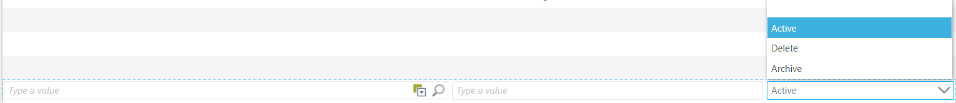

*Below is a sample of how to use it:*

After adding a Project Group, we proceed to create projects within this group. To do this, select the necessary project in the upper part of the screen and then click on the “Add” button on the toolbar at the bottom of the screen. It is also possible to edit existing projects.

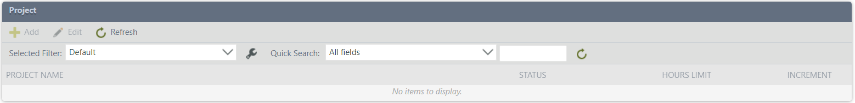

When adding or editing a Project, you have the opportunity to:

* Set a **“Status”** for the project, to enable archiving it or marking it as deleted if necessary.
* Access the **“Hours Limit”** feature, where you can specify a time limit available for the execution of tasks set for this project. The time is entered in Decimal format (e.g., 10.2).
* Finally, set the **“Increment”** – when logging the time spent on task execution, the system will round the entered time to the nearest value selected by you. This value can range from 5 minutes to 30 minutes.

*Below is a sample of how to use it:*

# Изображение выглядит как текст, снимок экрана, Шрифт Автоматически созданное описаниеMenu " Time Report User "

The next menu we will consider is 'Time Report User'. This menu is accessible only to those with the role of a Supervisor or Leader. This menu is designed for adding a work team and assigning roles to performers according to which they will have specific access to the features of this report. Also, this menu allows for the selection of projects on which the performer will work. In the upper part of the screen, when adding or editing an entry, a role is assigned to the Performer.

Only those with the roles of a Supervisor or Leader have access to all functions of the “Time Report”. In contrast, a Contractor has access only to the 'Log Time' and 'Dashboard' menus.

*Below is a sample of how to use it:*

In the lower part of the screen, when you select one of the performers, a list of available projects for work will be displayed. This list can be edited if necessary.

*Below is a sample of how to use it:*

# Изображение выглядит как текст, снимок экрана, Шрифт Автоматически созданное описаниеMenu " Time Report Inconsistencies "

The next menu we will consider is 'Time Report Inconsistencies'. This menu is accessible only to those with the role of a Supervisor or Leader. This menu provides the ability to identify discrepancies in data entered into two systems, Harvest and Noko. With the help of corresponding functional buttons, these discrepancies can be aligned.

